Digital Twin Runtime and Visualisation Layer
Figure 4-5 illustrates the Digital Twin Runtime and Visualisation Layer, which represents the logical and operational core of the SCION Digital Twin as a Service (DTaaS) platform. This layer is responsible for hosting Digital Twin execution logic, maintaining synchronisation between physical and digital entities, supporting analytics and reasoning functions, and providing user-facing visualisation and interaction interfaces. It builds directly on the virtualisation, SDN, and semantic-aware messaging layers described in Sections 4.2 to 4.4, translating data exchange and network control into actionable Digital Twin behaviour.
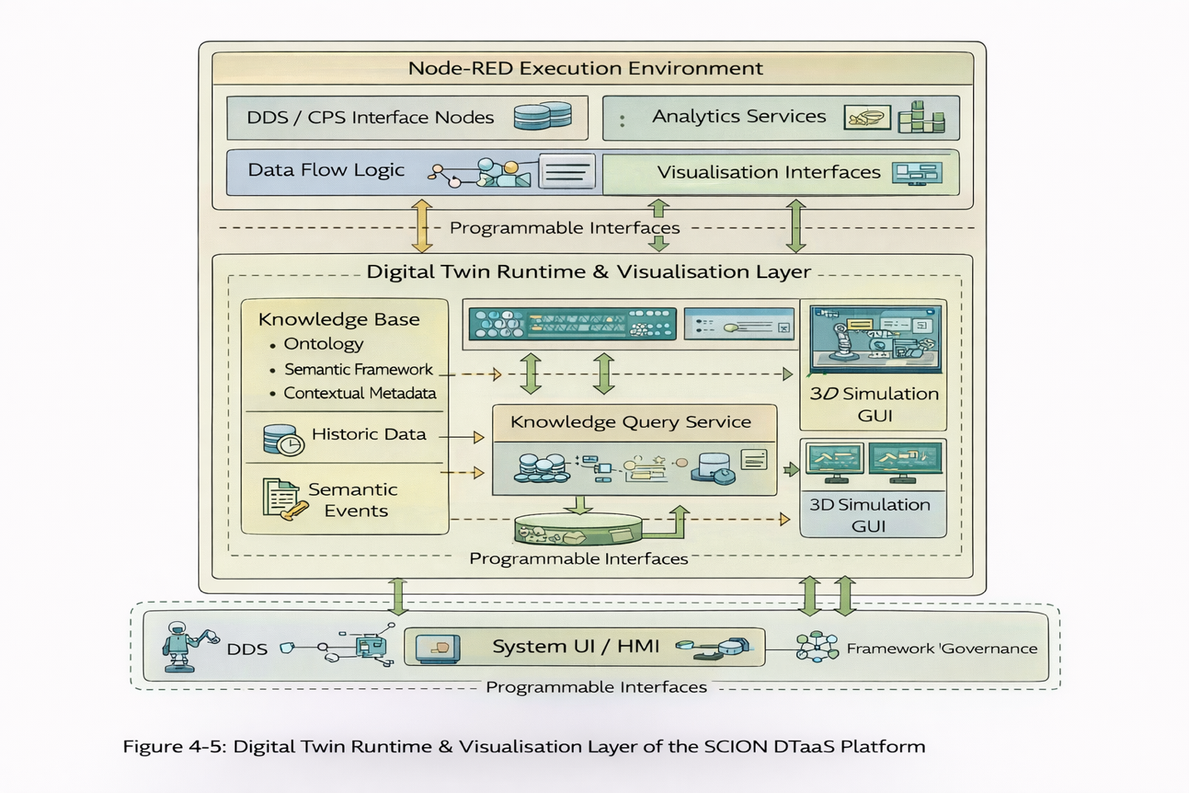
At the top of the figure, the Node-RED execution environment is shown as the primary runtime used to implement Digital Twins. Node-RED employs a flow-based programming model in which logic is constructed by connecting reusable blocks into event-driven workflows, making it well suited to rapid prototyping and iterative refinement of Digital Twin behaviour. Within this runtime, the platform hosts the functional components required to run a Digital Twin end to end, including DDS and CPS interface nodes, data-flow logic, analytics services, and visualisation views. Together, these components enable the Digital Twin to ingest telemetry, react to events, perform analysis, and expose results to users or downstream control functions.
The DDS and CPS interface nodes act as the bridge between the Digital Twin runtime and CPS systems that rely on real-time, data-centric communication. Their purpose is to abstract protocol-specific details and expose clean, structured data streams to the Digital Twin logic, allowing the twin to operate on consistent inputs even when underlying devices and transport mechanisms differ.
This capability is particularly important for Use Case 8, where coordination across networked CPS depends on timely and reliable updates. DDS is designed for this operational model. It is an open middleware standard defined by the OMG for publish–subscribe communication in real-time and embedded systems, and it provides Quality-of-Service policies that allow delivery behaviour to be tuned for latency, reliability, and timing constraints.
The Data Flow Logic block represents the processing pipelines within the runtime. This is where incoming telemetry is filtered, aggregated, correlated, and transformed into higher-level system state. Because the logic is flow-based, the Digital Twin can support both continuous monitoring and event-driven reactions. This mechanism keeps the digital representation aligned with changes in both the physical system and network conditions.
Alongside the data-flow pipelines, the runtime hosts Analytics Services. These services may include rule-based reasoning, statistical analysis, and AI- or machine-learning-assisted inference. In Use Case 2, analytics is where telemetry is transformed into network indicators, anomaly signals, and evidence for evaluating optimisation strategies. At the D7.1 stage, these analytics services are defined as plug-in components at the architectural level, ensuring that the platform remains open to different algorithms and implementation choices in later phases.
The Visualisation Interfaces embedded within the runtime provide dashboards and interaction points for operators, researchers, and system integrators. Node-RED is explicitly designed to collect, transform, and visualise real-time data, which aligns well with the dashboard role illustrated here. By keeping visualisation close to the runtime logic, the platform makes it easier to understand the current Digital Twin state and to trace how outputs are produced.
Below the Node-RED execution environment, Figure 4-5 expands into the broader Digital Twin Runtime and Visualisation Layer, which adds persistent knowledge management and richer system representations. A central component is the Knowledge Base, which stores structured knowledge required for contextual and semantic reasoning, including ontologies, contextual metadata, historical data, and semantic events. Ontologies may be expressed using languages such as OWL, which is designed to represent entities and relationships in a form that supports automated reasoning. This enables the Digital Twin to interpret raw telemetry within context rather than treating each measurement as an isolated value.
The Knowledge Query Service sits between the Knowledge Base and the rest of the runtime. It exposes programmable query interfaces that allow Digital Twin logic, analytics components, and visualisation tools to retrieve context, trends, and semantic relationships as needed. It also supports event-driven updates, enabling components to react to changes in knowledge without being tightly coupled to the storage layer.
On the right-hand side of the figure, 3D simulation and graphical user interfaces are shown as optional extensions. These components are not required for all deployments, but they become valuable when spatial relationships and dynamic behaviour must be understood quickly, for example during validation, training, or “what-if” analysis in complex CPS scenarios.
At the bottom of Figure 4-5, programmable interfaces connect the runtime to external systems, including system user interfaces and governance components. These interfaces allow governance functions such as access control, lifecycle management, and policy enforcement to interact with Digital Twin instances in a controlled manner. This supports multi-tenant operation and ensures that each Digital Twin operates within platform-defined constraints and policies. When these interfaces connect to industrial HMIs, they typically provide dashboards that allow users to monitor real-time data and interact with machines or systems.
From a use-case perspective, this runtime layer supports both Use Case 2 and Use Case 8. For Use Case 2, it hosts Network Digital Twin logic that interprets network telemetry, supports optimisation analysis, and presents network state to operators or automated controllers. For Use Case 8, it runs and coordinates CPS Digital Twins, maintains synchronisation with physical systems, and provides interfaces for monitoring, control, and adaptation.
In summary, Figure 4-5 illustrates how the SCION DTaaS platform realises Digital Twins as active, executable system components rather than passive models. By integrating runtime logic, analytics, knowledge management, and visualisation within a unified architectural layer, the platform provides a robust foundation for advanced Digital Twin applications while preserving modularity, scalability, and hardware independence. This layer serves as the primary interaction point between users, Digital Twin logic, and the underlying cyber-physical infrastructure, completing the end-to-end architecture described in this deliverable.

